The Department of Statistics at Florida State University invites applications for a tenure-track Assistant Professor specializing in Biostatistics for a nine-month appointment beginning August 2022. A Doctoral degree from an accredited institution or the highest degree appropriate in Statistics, Biostatistics, or a related field with a demonstrated record of achievement in teaching, academic research and service is required. The degree should be conferred before August 2022.
Please apply at www.jobs.fsu.edu (Job ID 49818). Additionally, three confidential independent letters of support are required to be sent through the FSU system. Review of applications begins immediately. The deadline for applications is 12/01/2021. An Equal Opportunity/Access/Affirmative Action/Pro Disabled & Veteran Employer. FSU’s Equal Opportunity Statement can be accessed at:
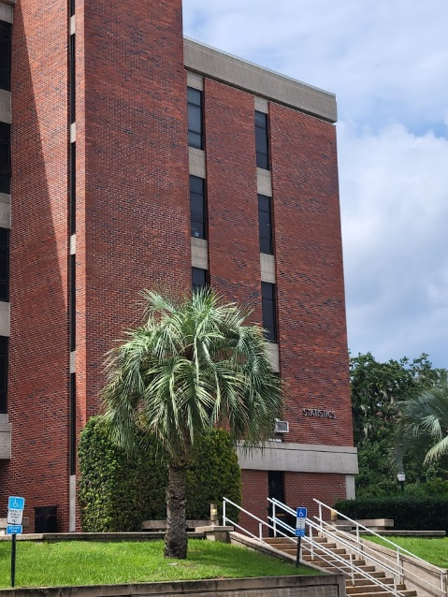
http://www.hr.fsu.edu/PDF/Publications/diversity/EEO_Statement.pdf
One of the nation's elite research universities, Florida State University preserves, expands, and disseminates knowledge in the sciences, technology, arts, humanities, and professions, while embracing a philosophy of learning strongly rooted in the traditions of the liberal arts and critical thinking. Founded in 1851, Florida State University is the oldest continuous site of higher education in Florida. FSU is a community steeped in tradition that fosters research, encourages creativity, and embraces diversity. At FSU, there’s the excitement of being part of a vibrant academic and professional community, surrounded by people whose ideas are shaping tomorrow’s news!
Learn more about our university and campuses.

